Dear Team,
Following our last meeting and the subsequent request for updated NAME model input parameters, please find below a summary of the revised simulation text input parameters. These updates align with Benoit’s recommendations and incorporate plume height percentile estimates derived from satellite, infrasound, VONA, and probabilistic forecast data.
In addition, I have attached a zip folder containing the complete input datasets provided by both the Infrasound and Satellite teams. This folder also includes the corresponding simulation text input files and output simulation results for your reference.

1. Satellite-Derived Input Parameters
When plume height is estimated from satellite or infrasound sources, we use the 5th, 50th, and 95th percentile plume heights alongside the eruption duration.
Data Source: Satellite Team
The satellite team provided hourly mean and standard deviations of plume heights. From these, we calculated the plume height percentiles and estimated eruption duration as outlined below.
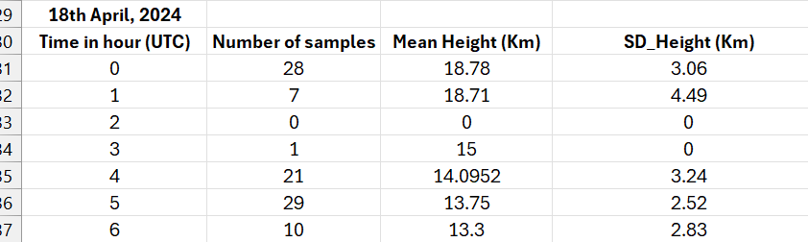

Eruption reported to start at 00:00 AM and end at 6:00AM on January April 18th, 2024, >> duration of 6 hours and 0 minutes
We have data as hourly mean and std for the plume height since start of eruption.
Time in UTC /hours since onset / Mean-H / STD-H
0 from 0:00 to 1:00 / 18.78 / 3.06
1 from 1:00 to 2:00 / 18.71 / 4.49

Etc …

simulationStartDatetime 20250418_0000
simulationDurationInHour 24
volcanoName Ruang_273070
volcanoX 125.36667
volcanoY 2.30306
summitHeightInMetre 725
simulationDomain_xMin 90.0
simulationDomain_xMax 160.0
simulationDomain_yMin -15.0
simulationDomain_yMax 40.0
outputGridSize_dX 0.25
outputGridSize_dY 0.25

### 5th percentile ->

emissionSourceParameterSet_1 13746_01_00_2025_04_18_00_00
emissionSourceParameterSet_2 11323_01_00_2025_04_18_01_00
### 50th percentile ->
emissionSourceParameterSet_1 18780_01_00_2025_04_18_00_00
emissionSourceParameterSet_2 18710_01_00_2025_04_18_01_00

### 95th percentile ->
emissionSourceParameterSet_1 23813_01_00_2025_04_18_00_00
emissionSourceParameterSet_2 26096_01_00_2025_04_18_01_00

2. Infrasound-Derived Input Parameters
Infrasound data provides timestamps corresponding to plume heights calculated as the average across 30 minutes before and after each timestamp.
For example, the first timestamp as example:
2020 1 12 8 23 32
It means the calculation was based on the 30-minute period 2020/01/12 08:08:32 - 08:38:32 UTC.

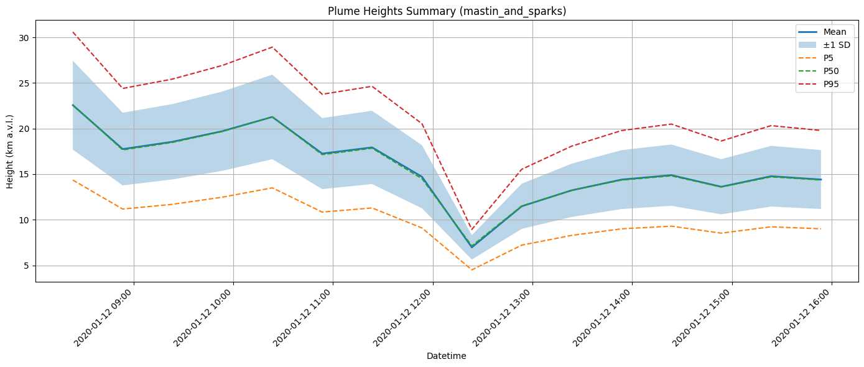
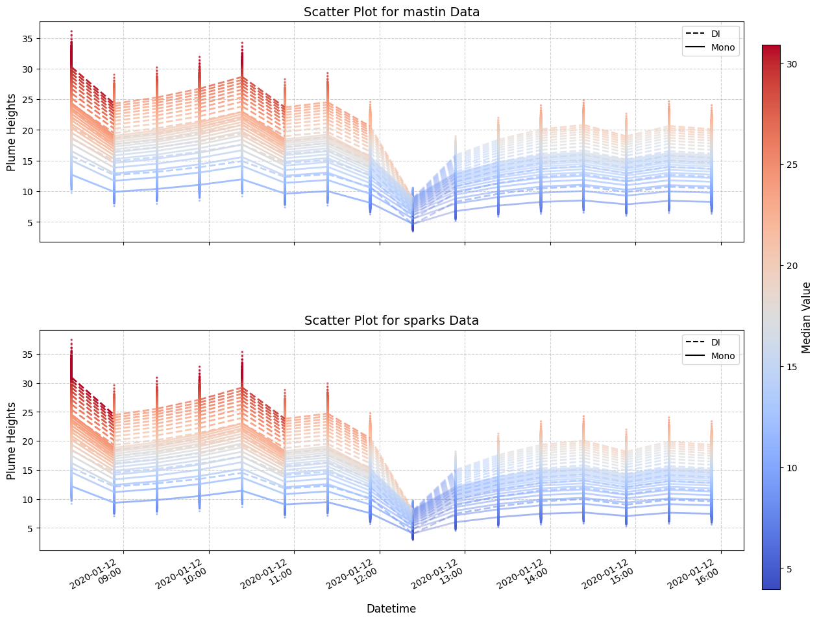
Example Name Model output for Infrasound data
simulationStartDatetime 20200112_0823
simulationDurationInHour 24
volcanoName TAAL_273070
volcanoX 105.4
volcanoY -6.1
summitHeightInMetre 1800
simulationDomain_xMin 90.0
simulationDomain_xMax 160.0
simulationDomain_yMin -15.0
simulationDomain_yMax 40.0
outputGridSize_dX 0.25
outputGridSize_dY 0.25
# ## 5th Percentile
emissionSourceParameterSet_1 14353_00_30_2020_01_12_08_23
emissionSourceParameterSet_2 11169_00_30_2020_01_12_08_53
emissionSourceParameterSet_3 11692_00_30_2020_01_12_09_23
emissionSourceParameterSet_4 12474_00_30_2020_01_12_09_53
# ## 50th Percentile
emissionSourceParameterSet_1 22604_00_30_2020_01_12_08_23
emissionSourceParameterSet_2 17656_00_30_2020_01_12_08_53
emissionSourceParameterSet_3 18480_00_30_2020_01_12_09_23
emissionSourceParameterSet_4 19676_00_30_2020_01_12_09_53

### 95th Percentile
emissionSourceParameterSet_1 30592_00_30_2020_01_12_08_23
emissionSourceParameterSet_2 24399_00_30_2020_01_12_08_53
emissionSourceParameterSet_3 25432_00_30_2020_01_12_09_23
emissionSourceParameterSet_4 26927_00_30_2020_01_12_09_53

3. Probabilistic Forecast Input Parameters (Volcano Name & Location Only)
When only the volcano name and coordinates are known, eruption duration and plume height percentiles are estimated using Bayesian statistics with prior distributions (Mastin, Sparks, Aubrey databases).
simulationStartDatetime 20250618_2037
simulationDurationInHour 168
volcanoName TAAL
volcanoX 120.993333
volcanoY 14.001666
summitHeightInMetre 311
simulationDomain_xMin 90.0
simulationDomain_xMax 160.0
simulationDomain_yMin -15.0
simulationDomain_yMax 40.0
outputGridSize_dX 0.25
outputGridSize_dY 0.25
emissionSourceParameterSet TO_BE_UPDATED
## 5th percentile
# VEI 2
emissionSourceParameterSet_1 5764_2_54_2025_06_18_20_37
# VEI 3
emissionSourceParameterSet_2 8925_1_36_2025_06_18_20_37
# VEI 4
emissionSourceParameterSet_3 13441_0_45_2025_06_18_20_37

## 50th Percentile
# VEI 2
emissionSourceParameterSet_1 5764_3_56_2025_06_18_20_37
# VEI 3
emissionSourceParameterSet_2 8925_2_13_2025_06_18_20_37
# VEI 4
emissionSourceParameterSet_3 13441_1_11_2025_06_18_20_37
## 95th Percentile
# VEI 2
emissionSourceParameterSet_1 5764_5_22_2025_06_18_20_37
# VEI 3
emissionSourceParameterSet_2 8925_3_5_2025_06_18_20_37
# VEI 4
emissionSourceParameterSet_3 13441_1_50_2025_06_18_20_37

4. VONA-Based Input Parameters
When using VONA observations, we directly use observed plume heights and user-defined eruption durations or forecasted eruption duration given the observed Plume height.

Same as above only difference we are directly using observed VONA Plume height and user defined eruption duration.
simulationStartDatetime 20250618_2203
simulationDurationInHour 168
volcanoName Semeru__263300_
volcanoX 112.92
volcanoY -8.108055555555556
summitHeightInMetre 3676
simulationDomain_xMin 90.0
simulationDomain_xMax 160.0
simulationDomain_yMin -15.0
simulationDomain_yMax 40.0
outputGridSize_dX 0.25
outputGridSize_dY 0.25

# 5th percentile
emissionSourceParameterSet_1 800_17_46_2025_06_18_22_03
# 50th percentile
emissionSourceParameterSet_1 800_38_46_2025_06_18_22_03
# 95th percentile
emissionSourceParameterSet_1 800_84_5_2025_06_18_22_03

